Project AIMESS Application |  |  | 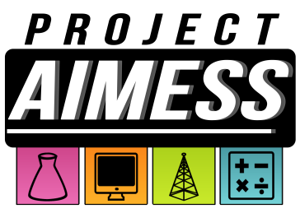
Name
Current Teacher
Street Address
City/ZIP
Home Phone
Parent Work Phone
Parent Cell Phone
Parent E-Mail Address

Interests

Tell us in which area(s) you are interested in pursuing!
Science  Social Studies  English | Mathematics  ___ Music  Other: ______________________________

Activities

What other programs and activities are you involved in? What do you like to do?

Previous STEM Experience

Please let us know what other programs, activities, and even competitions you have participated in how you liked them!

Person to Notify in Case of Emergency
Name
Street Address
City ST ZIP Code
Home Phone
Work Phone
E-Mail Address

Miscellaneous
Allergies
Other Health-Related
Information
Anything else you’d like us to know? What makes you YOU?

Teacher Recommendation
Teacher Name
Grade Taught
Please rate the student in the following categories (please circle one):
Focused on STEM | Strongly Disagree Disagree Agree Strongly Agree
Well-Behaved | Strongly Disagree Disagree Agree Strongly Agree
Works Well with Others | Strongly Disagree Disagree Agree Strongly Agree
Please write a few sentences in regard to the student’s interest in STEM and his/her work ethic and behavior.

Teacher Name (print): ____________________________________________________
Teacher Signature: ______________________________________________________
Parent Signature: _______________________________________________________
Student Signature: ______________________________________________________

