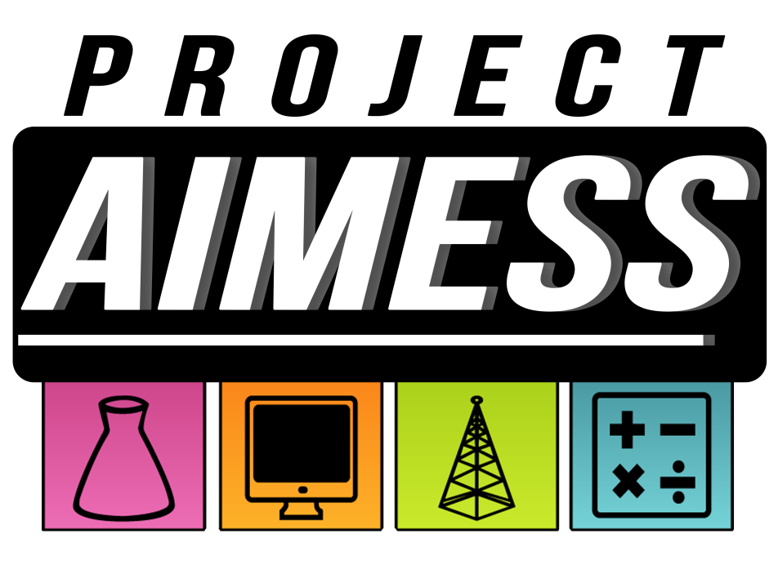
Science + Learning = Fun!

Project AIMESS is a STEM initiative created by Battlefield High School seniors Aaron Guo and Kayla Townsend. AIMESS stands for the “advancement of in-depth math, engineering, and science skills.”

In this program, we are looking for select 5th graders with an expressed interest and ability in STEM (science, technology, engineering, and math) skills. Through bi-weekly afterschool sessions, we will work with students to explore potential college and career interests. In today’s society, as technology advances ever so quickly, the demand for employees in STEM-related businesses is rapidly increasing. To give our local children a greater chance of being prosperous in their futures in these careers, we believe it is important to foster and cater to their interests at an early age.

In these bi-weekly sessions, we will:
- introduce a certain field of science, technology, engineering, or math,
- explain the possible career opportunities in the field,
- explain how the field is important to our everyday lives
- explore that field through an exciting, interactive, hands-on experiment that will simulate the work done by those in that occupation.

We hope that through Project AIMESS, your child will be able develop and further the skills to become a successful and highly sought after individual in the growing world of modern science, technology, engineering, and math.

If interested, we would like your child to fill out the following application to be carefully considered for one of 20 spots in this program, and return it to his/her teacher by September 28th, 2012.

If you have any questions feel free to contact Aaron (email: aaron.guo@gmail.com; cell: 240-654-2422) or Kayla (email: kaygurl9@hotmail.com; cell: 703-986-9543). We hope to see you soon!

